**MN521 Network Automation**

Laboratory 5: Introduction to Git

MIT251002 Erdenebayar Dovchindorj

1. **Part 1**
   1. Initializing a Git Repository Locally
      1. Initialize a local Git Repo



* + 1. Create a New File



* + 1. Add and Commit the file

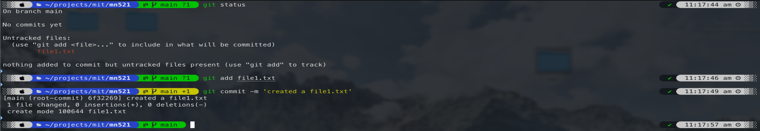

* 1. Making and Viewing Changes Locally
     1. Edit the File





* + 1. Check git status

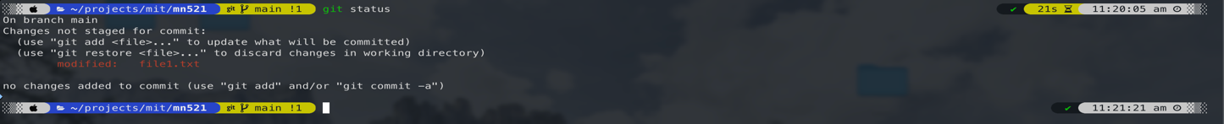

* + 1. Stage and commit changes

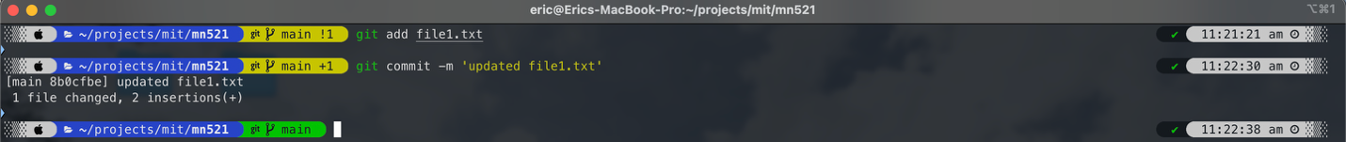

* + 1. View Commit History

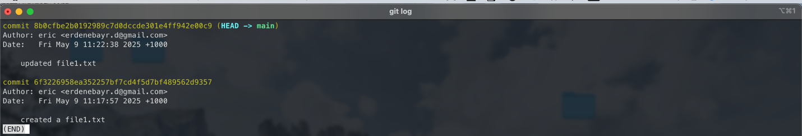

* 1. Accidentally Deleting and Recovering files locally
     1. Accidentally delete a file

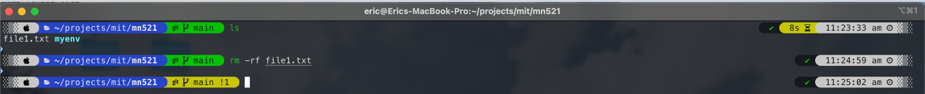

* + 1. Recover the Deleted file



* + 1. Commit the Restored file



* 1. Restoring to a Particular Version Locally
     1. Find the commit hash or Tag

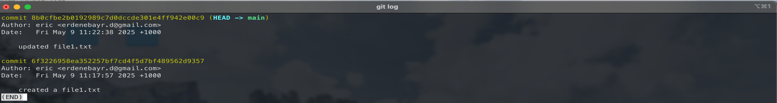

* + 1. Copy the Commit Hash or Tag



* + 1. Use git checkout to Restore the file commit



* + 1. Verify the changes

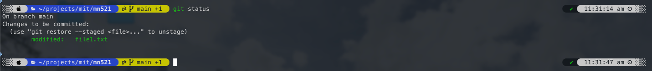

* + 1. Commit the Restored file

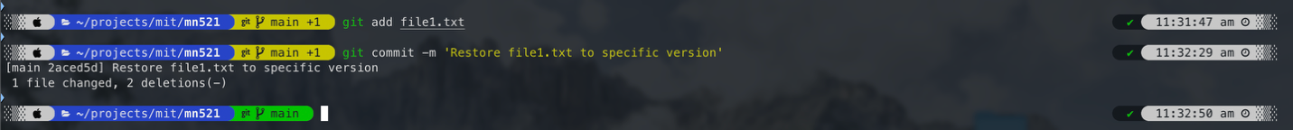

1. **Part 2**
   1. Set Up an Online Gitlab Repository
      1. Create a Gitlab Account

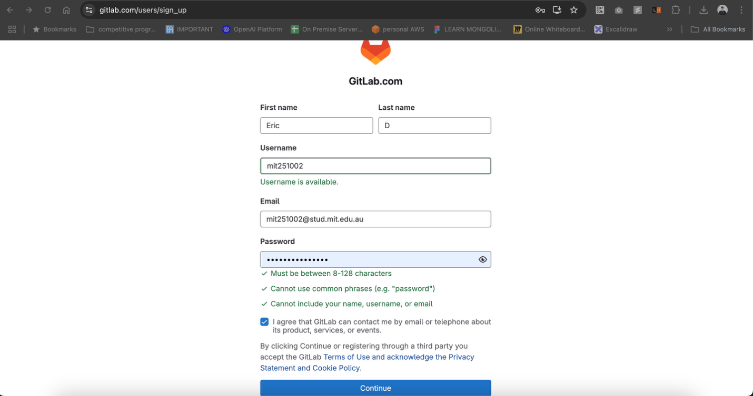

* + 1. Create a New Project

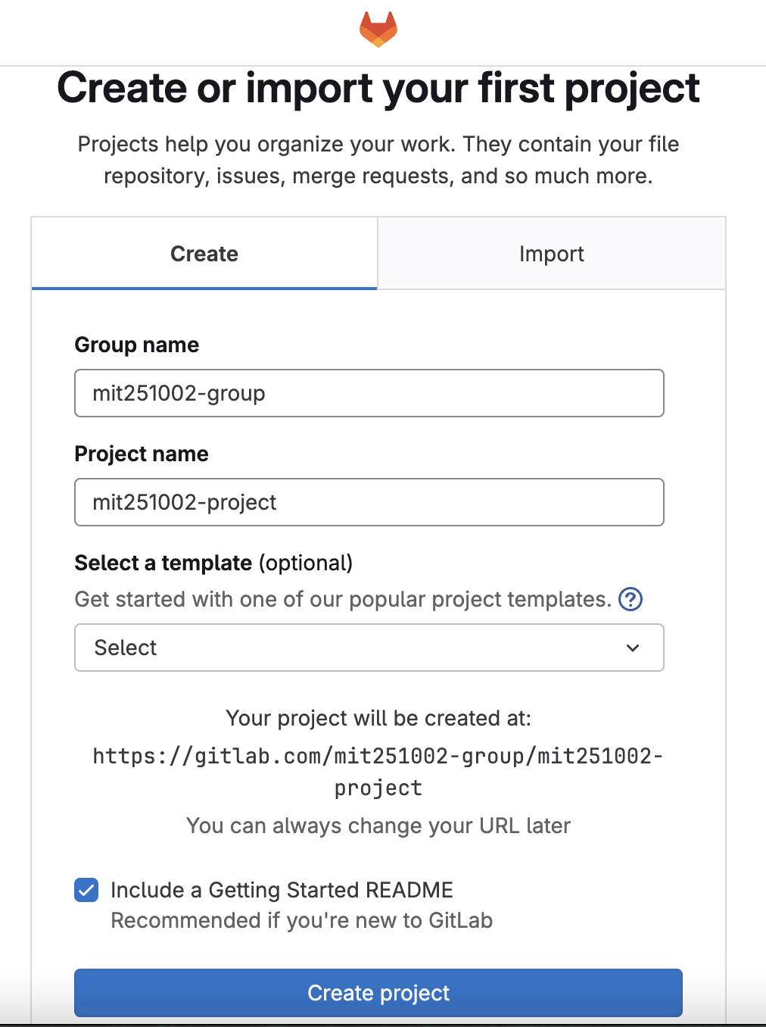

* + 1. Connect Local and Online Repositories

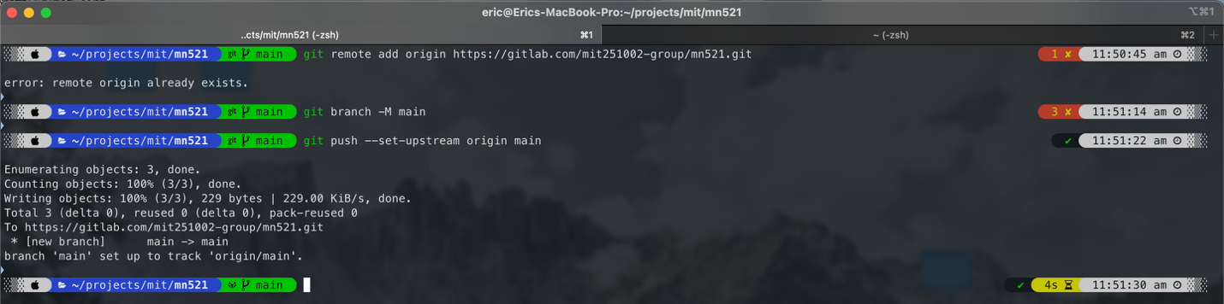

* 1. Push Changes to Online Repository
     1. Push local Changes to Gitlab

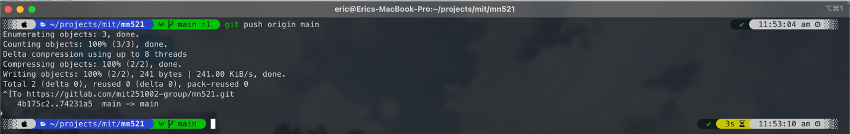

* 1. Deleting and Recovering Files on Gitlab
     1. Delete a File on Gitlab

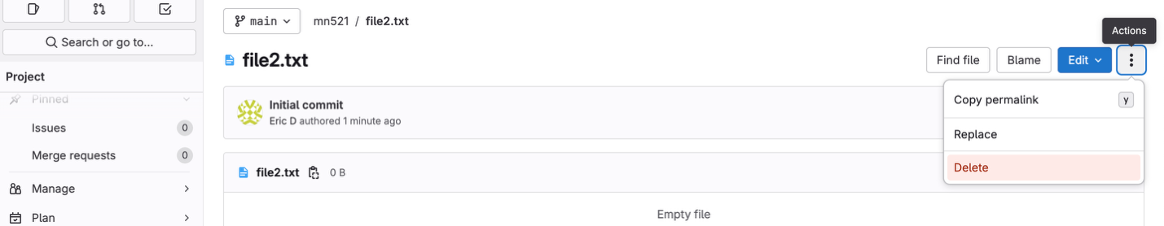

* + 1. Navigate to Gitlab and delete file1.txt through the interface

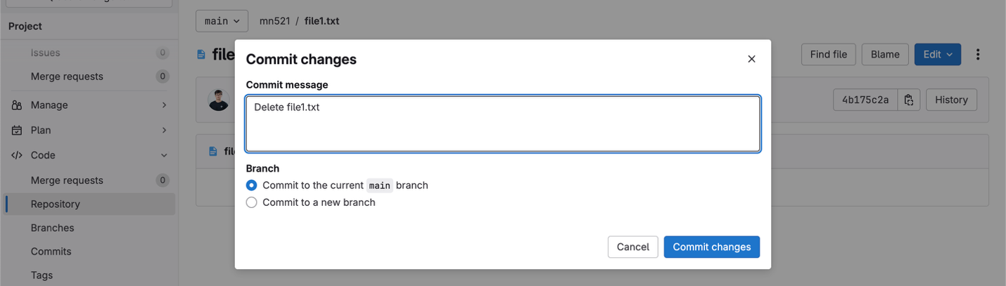

* + 1. Sync changes Locally



* + 1. Run the “git pull origin main” command to fetch and merge the changes made on Gitlab (remote repo)

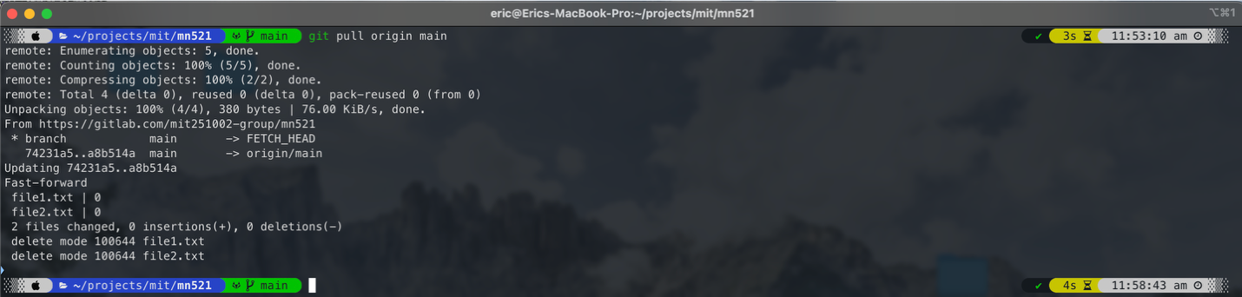

* + 1. Recover the deleted files



* + 1. If needed, restore the deleted file (it’s same as E)



* 1. Restoring to a Particular Version on Gitlab
     1. Find the commit hash or tag on Gitlab

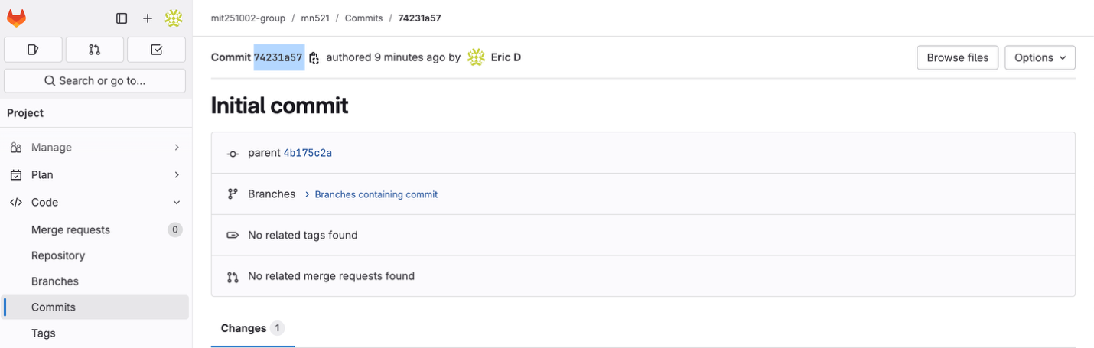

* + 1. Use Gitlab’s interface or commands to find the hash or tag of the version

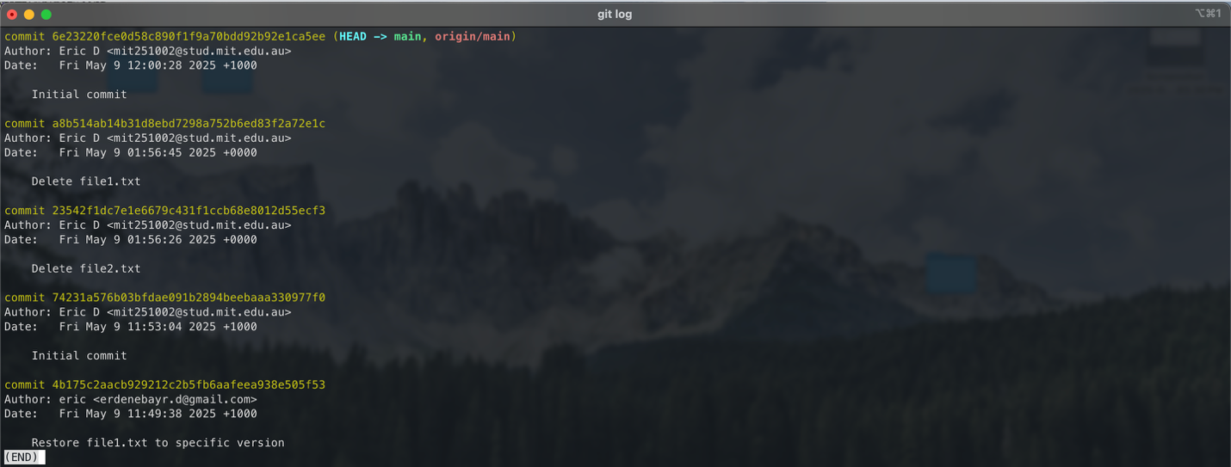

* + 1. Copy the commit hash or tag



* + 1. Use git checkout to Restore the file on Gitlab



* + 1. Verify the changes on Gitlab

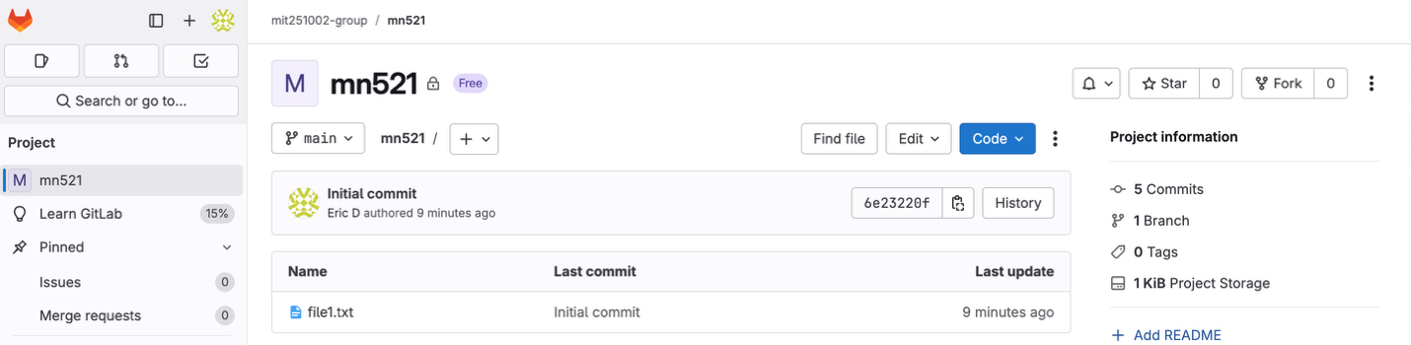

* + 1. Commit the restored file on Gitlab

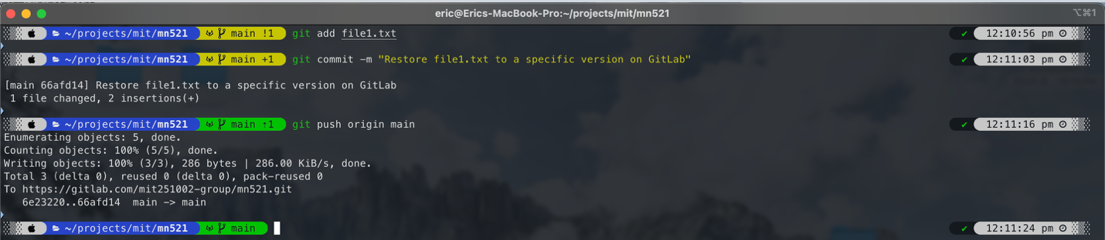

* 1. Forcing Overwrite of Local changes when restoring to Particular Version on Gitlab
     1. Make local Repo is out of Sync



* + 1. Attempt to Restore to a Specific Version



* + 1. Handle conflict and Force Overwrite



* + 1. Verify changes

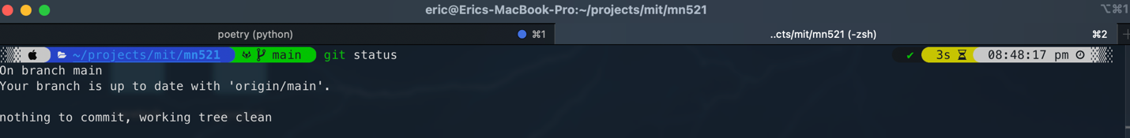

* + 1. Commit the restored file

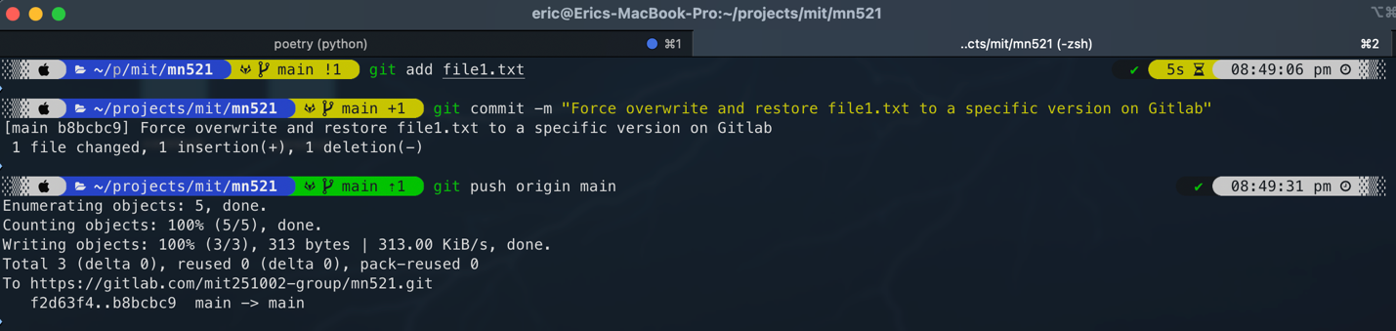

* 1. Demonstrating Git Rebase on Gitlab (command line)
     1. Clone the Gitlab repo to your local machine

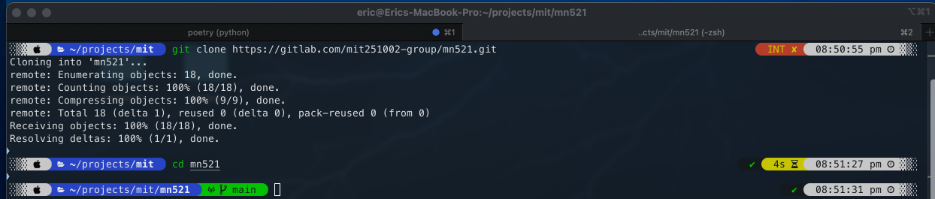

* + 1. Create a new branch named feature-branch

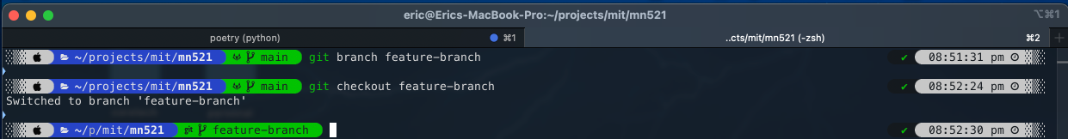

* + 1. Make Changes in the Feature branch

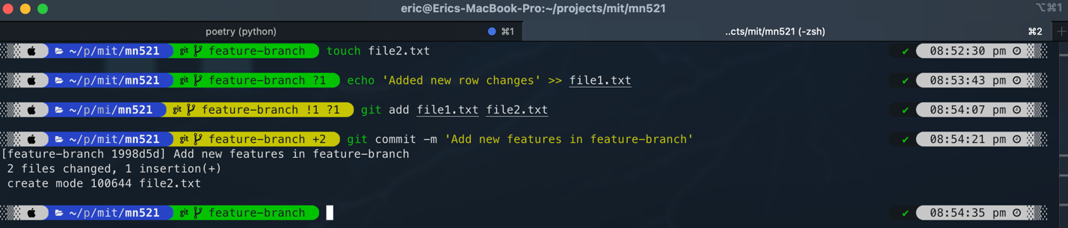

* + 1. Fetch and Rebase

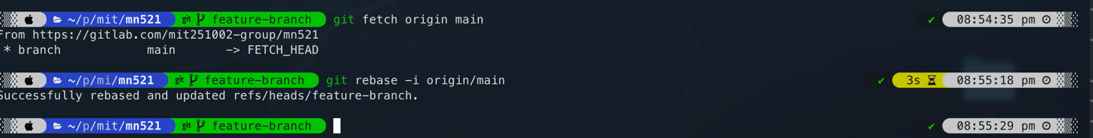

* + 1. Resolve Conflicts (if any)

Since there is no conflict as shown as above screen shot, nothing to do

* + 1. Push changes to Gitlab

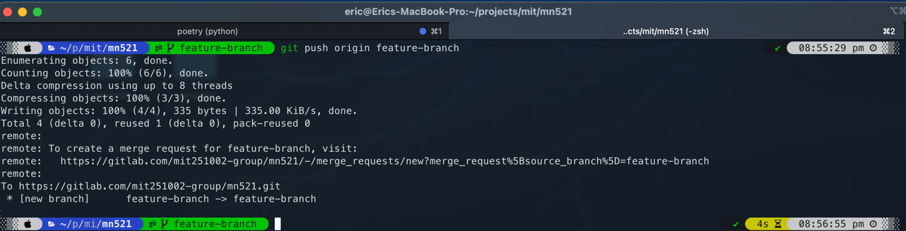

* 1. Demonstrating Git Reset on Gitlab (Command Line)
     1. Make Undesired Changes on Gitlab



* + 1. Reset to a Previous Commit on Gitlab

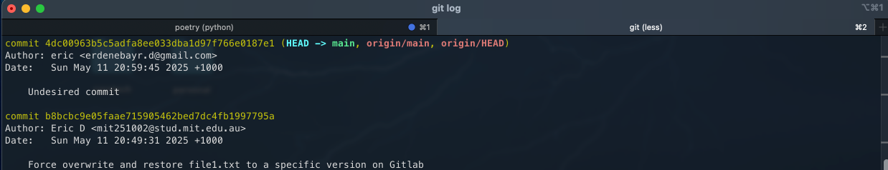

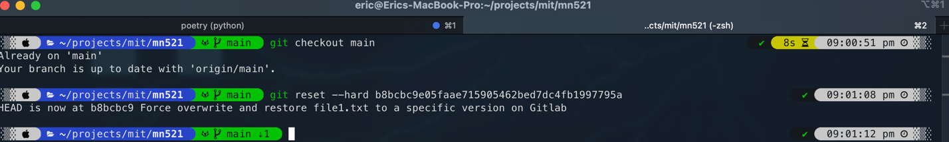

* + 1. Verify. The Reset

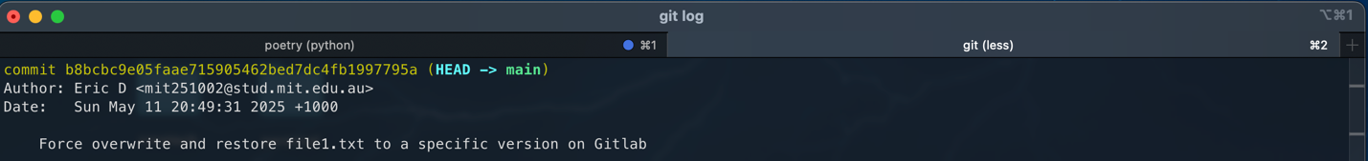

* + 1. Force-Push Changes on Gitlab

